Operating Systems Project – PHASE 2 Report
Phase 2 — Servers Configuration
Server setup and configuration tasks will be completed in Phase
- Server to configure:
- Proxy Server
INTRODUCTION
A Proxy Server acts as an intermediary between client systems and the internet. It improves network performance, enhances security, and enables access control by filtering web traffic. Proxy servers can also cache frequently accessed web content, reducing bandwidth usage and improving response time. In this task, a Proxy Server is configured on Ubuntu using Squid.

IMPLEMENTATION

Role Assignment
Ubuntu 1 → Proxy Server
Ubuntu 2 → Proxy Client

Proxy Server IP → 192.168108.130
Proxy Port → 3128

Step 1 – Install Proxy Server (Squid) – Ubuntu 1
sudo apt update
sudo apt install squid -y
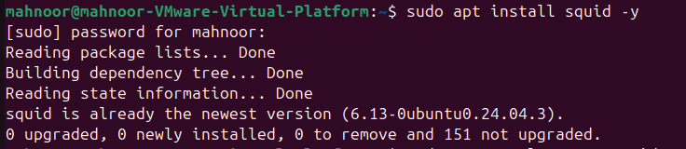
Step 2 – Check Proxy Service Status
sudo systemctl status squid
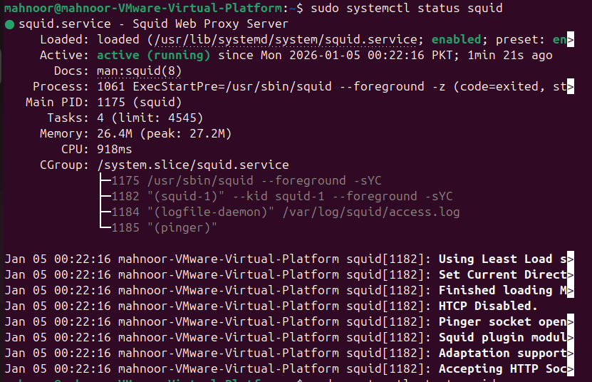
sudo systemctl restart squid
sudo systemctl enable squid
Step 3 – Configure Squid Proxy
sudo nano /etc/squid/squid.conf
acl mynetwork src 192.168.108.0/24
http_access allow mynetwork
http_access deny all
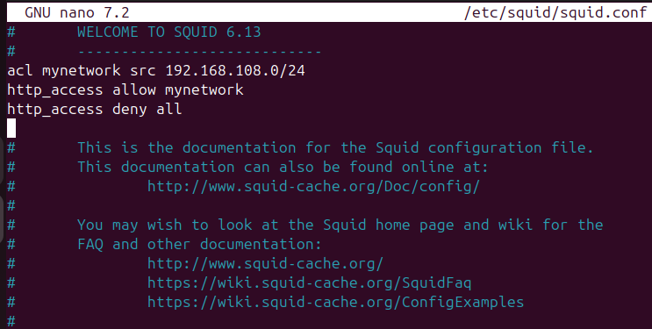

Step 4 – Restart Proxy Service
sudo systemctl restart squid
sudo systemctl status squid
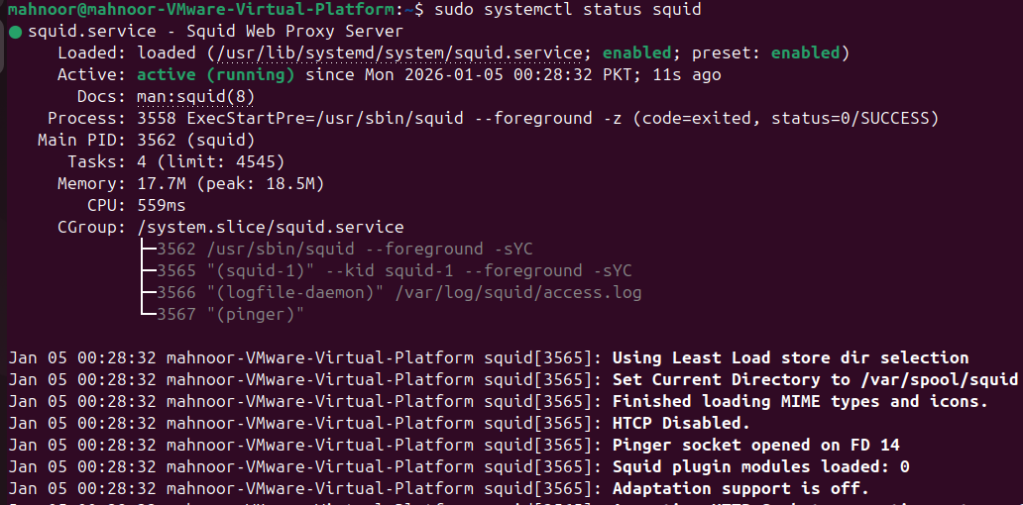
sudo ufw allow 3128/tcp

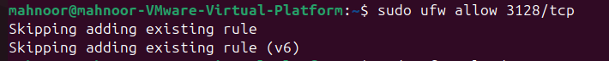
sudo ufw reload
Step 5 – Configure Proxy Client – Ubuntu 2
export http_proxy="http://192.168.25.131:3128"
export https_proxy="http://192.168.25.131:3128"
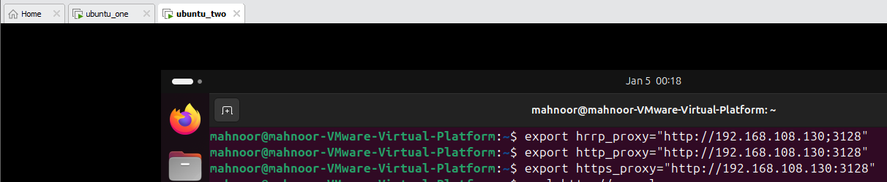
sudo apt update
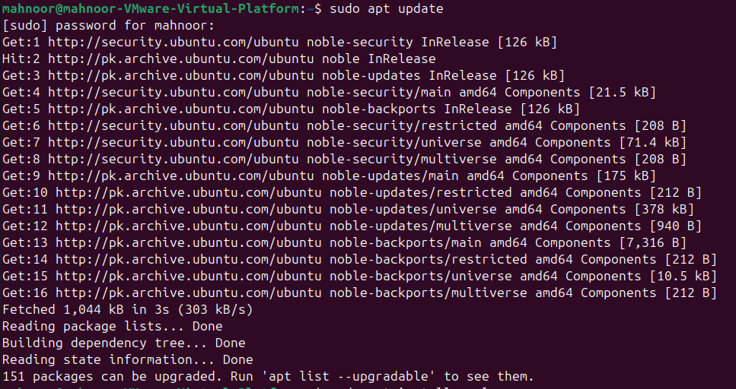
sudo apt install curl -y
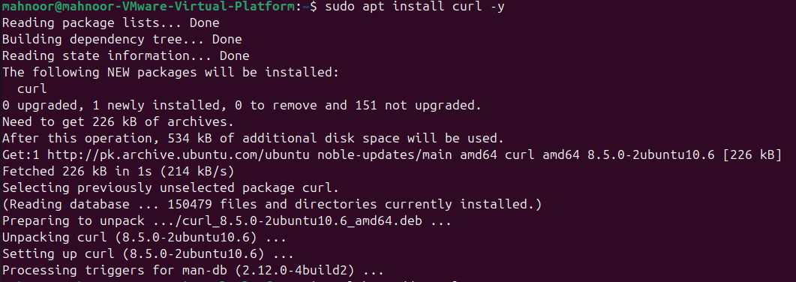

Step 6 – Test Proxy
curl http://example.com
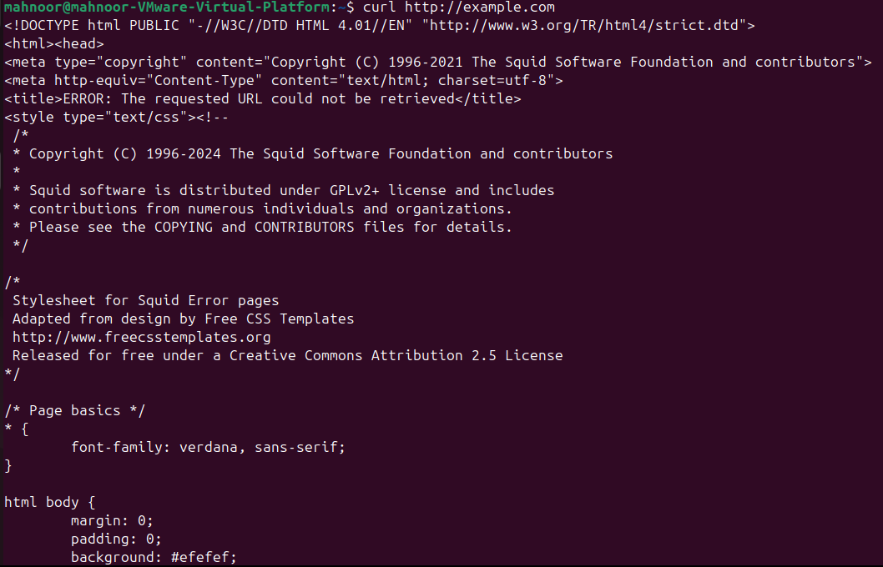

CONCLUSION
The Proxy Server was successfully configured on Ubuntu using Squid. Client systems accessed the internet through the proxy server, confirming correct functionality.
_____________________________________________________________________

